 | Grangetown Primary School
 | Grangetown Primary
 | St Georges Road
 | Grangetown
 | MIDDLESBROUGH
 | North Yorkshire
 | TS6 7JA
24 October 2019 | Email: office@grangetownprimary.org.uk
 | Phone: 01642455278
 | Website:
 | http://www.grangetownprimaryschool.co.uk/
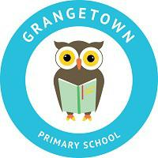
Throughout our PSHE curriculum, we will be covering a range of themes. We are just sending this letter out to inform you of what your child will be learning this year.

PSHE OVERVIEW YEAR 3 & 4: The learning opportunities for each core theme have been grouped together into topics.

CORE THEME 1: Health and Wellbeing

Topic Areas: Healthy Lifestyles

- How to be healthy

- Health wellbeing and Hygiene

Keeping Safe

*Pressure, Influences, Media, Peer

*Risk, Danger, Hazard

*Rules

*Online Safety

Growing and Changing

*Change, Transition, Loss, Separation, Bereavement

*Physical and emotional changes

CORE THEME 2: Relationships

Topic Areas: Feelings and Emotions

*Healthy Relationships

*Positive Relationships

*Acceptable / Unacceptable touching

Valuing Difference

*Bullying

*Stereotypes

CORE THEME 3: Living in the wider world

Topic Areas: Rights and Responsibilities

*Children’s Rights

*Taking care of the environment

*Diversity and People’s differences

*Media & Social Media

