 | Grangetown Primary School
 | Grangetown Primary
 | St Georges Road
 | Grangetown
 | MIDDLESBROUGH
 | North Yorkshire
 | TS6 7JA
24 October 2019 | Email: office@grangetownprimary.org.uk
 | Phone: 01642455278
 | Website:
 | http://www.grangetownprimaryschool.co.uk/
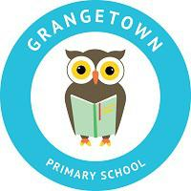
Throughout our PSHE curriculum, we will be covering a range of themes. We are just sending this letter out to inform you of what your child will be learning this year.

PSHE OVERVIEW YEAR 1/2

The learning opportunities for each core theme have been grouped together into topics.

CORE THEME 1: Health and Wellbeing

Topic Areas: Healthy Lifestyles

- Health wellbeing and Hygiene

- Feelings and emotions Keeping Safe

*Road Safety *Asking for help Growing and Changing

*Correct terminology of body parts *Change and loss

CORE THEME 2: Relationships

Topic Areas: Feelings and Emotions

*Communication, feelings and empathy

*Teasing, Bullying

Healthy Relationships

*Physical contact, touch, acceptable, unacceptable

*Cooperation, resolving argument

Valuing Difference

*People, similarities and differences

CORE THEME 3: Living in the Wider World

Topic Areas: Rights and Responsibilities

*Everybody, individual, unique, special

*Community, special people, emergencies

Taking Care of the Environment

*Money

