

Dear Parent or Carer
Re: School Fluoride Varnish Programme
In partnership with The Eston Dental Practice and NHS Tees we are about to run a dental programme to help protect your child’s teeth against tooth decay. This will be done by applying fluoride varnish to your child’s teeth if you wish your child to benefit from this programme, this programme is open to children from Nursery – Year 6.
This initiative has been proven to reduce tooth decay rates in children’s permanent teeth by up to 46%. It is a sticky fruity flavoured varnish that is applied using a tiny paint brush onto your child’s teeth. It is a very simple procedure, taking only a few minutes. Most children find it very enjoyable. All children will be offered the opportunity to participate in this 3 year programme which will involve twice yearly applications of the fluoride varnish at school.
Your school has been chosen because it runs other health initiatives to improve children’s oral health such as Tooth Brushing at school and the Smile Sack.
Please can you fill out the form attached if you would like your child to benefit from this. If you would like to discuss the fluoride varnish programme, please call the dental practice on 01642 466766 to find out more information.
Please return this form back to school by Tuesday 11th June.
This Programme will be on Wednesday 12th June.
Yours sincerely
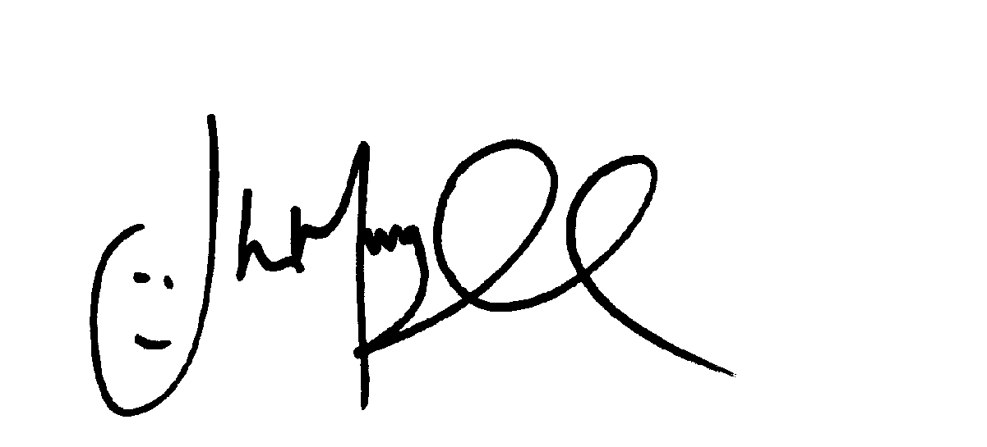
Mr J Murgatroyd
Head Teacher

