29th March 2019

Dear Parents/Carers

As part of their topic on Food the children in Y4 will be sampling different Greek foods in class. Please inform school if your child has any food allergies or intolerances, or if you do not want them to take part in the food sampling.

Yours sincerely
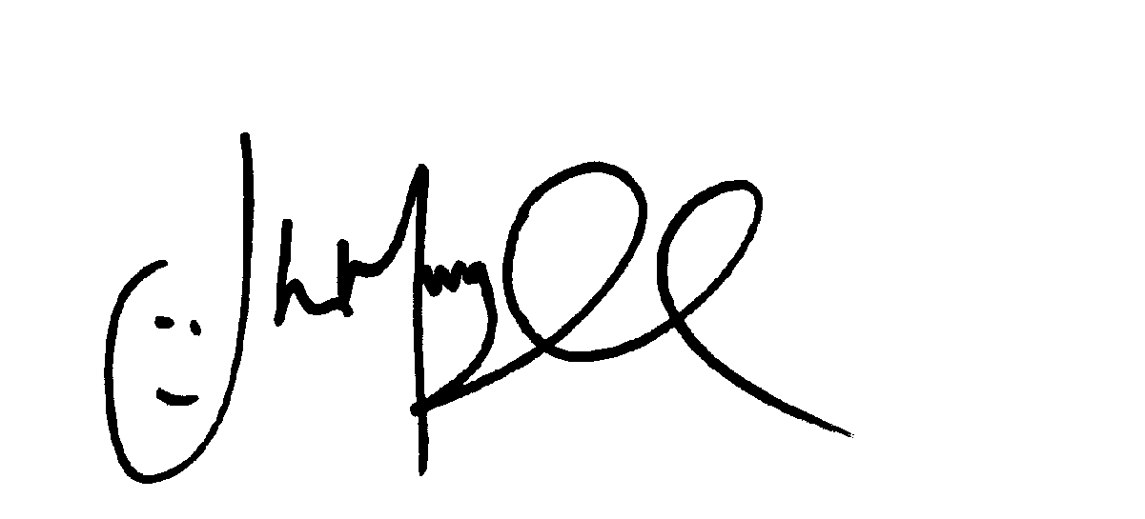
Mr J Murgatroyd
Head Teacher

