26th March 2019

Dear Parents and Carers

St Hilda’s Church

As part of our Easter celebrations all of the children in school will be walking to St Hilda’s Church to watch Year 3 children do a singing performance on the morning of Thursday 4th April. The performance will start at 10.00 am.

As the children are walking, please can you ensure your child is wearing a waterproof warm coat and sensible shoes.

We would like to extend a special welcome to all parents and carers to join us at St Hilda’s Church to watch the performance.

Please note the children in Year 3 will also be walking to the Church on the morning of Tuesday 2ndApril for a dress rehearsal.

If you do not want your child to take part in the visit to the Church, please inform their class teacher.

Yours sincerely
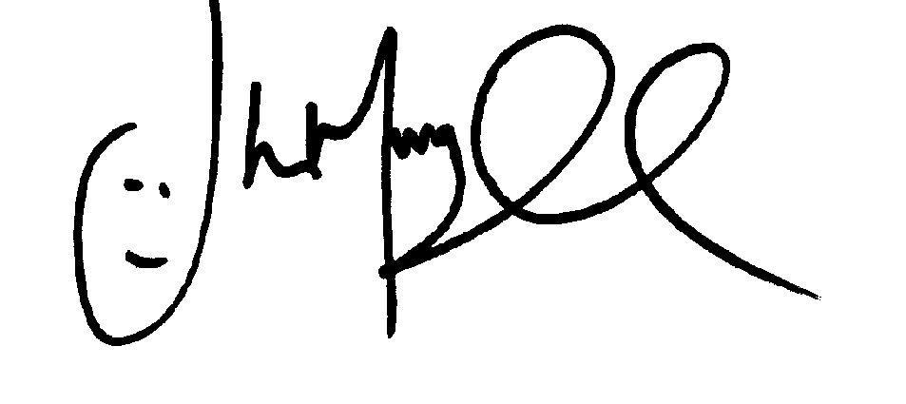
Mr J Murgatroyd
Head Teacher

