2019

Dear Parent of

Re: School: Grangetown Primary

Grangetown Primary have contacted you previously on at least two occasions by letter/ telephone / home visits, to make you aware of school’s concern regarding __________’ attendance. The necessary improvements have not been made and this is now a serious matter.

_________’s attendance is now % (Please see enclosed attendance certificate).

Every pupil at this school, is required to maintain an attendance level of 96% and above. __________ is now a persistent absentee, which could result in their education being at risk. Good attendance is essential for progress in learning and for the development of self-discipline and positive work habits. As you are aware, it is a Parent/Carer’s obligation to ensure your child attends school.

As you are aware Grangetown Primary is now unable to authorise any further absences without evidence, ie medical/dental appointment cards, labels from medication (with the relevant dates), prescription notes and the like. Any application for holidays during term time may also be declined.

It is imperative that _________ immediately starts attending school on a regular basis. Should this matter remain unresolved, the Trust’s Attendance and Welfare Officer will commence formal proceedings by holding an Attendance Case Conference meeting in school.

It is extremely important that you contact myself or Miss Mott to discuss the problems and make a plan to improve ____________’s school attendance.

Yours sincerely
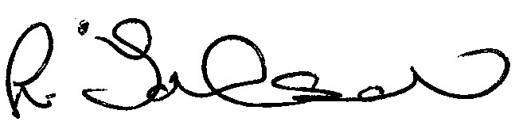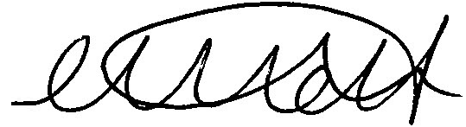
Lisa Johnson Miss C Mott
Attendance and Welfare Officer Deputy Head

