2019

Dear Parent of ____________________

According to our records __PUPIL NAME__ has been absent from school for _____ sessions (please see enclosed attendance certificate).

__PUPIL NAME__’s attendance is currently _____%.

When your child is absent, it is important that you contact us with a reason. Failure to provide an acceptable reason for absence will result in that absence being recorded as unauthorised.

School attendance is vital to ensure that children remain safe, achieve their full potential and improve life chances. As a Parent/Carer, you commit an offence if you fail to ensure your child attends school regularly. Failure to do so may result in a referral to the Attendance and Welfare Officer. We wish to work in partnership with you to avoid this.

We trust you will ensure your child attends school on a regular basis from now on. If, however, you have any concerns or feel you need assistance, please do not hesitate to contact myself or Miss Mott regarding this matter.

Yours sincerely
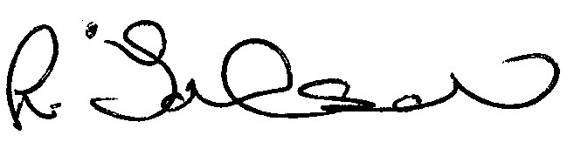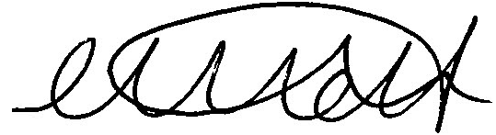
Lisa Johnson Miss C Mott
Attendance and Welfare Officer Deputy Head

