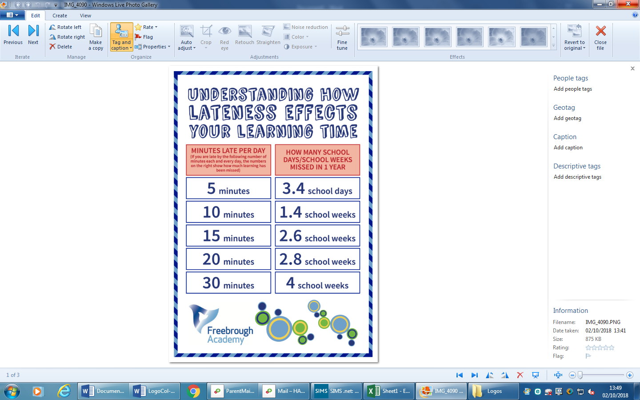



**Please be aware if your child arrives after 9:10am they will be given a late mark in the register.**

**If your child arrives after 9.45am they will be given an unauthorised absence mark which will impact on their attendance.**