22nd March 2018

Dear Parents and Carers

Y4/5 France Trip Reminder

I am writing to remind all parents that the final balance of £40.00 for the France trip is required by Tuesday 15th May.

If you need to make any financial arrangements or talk about any concerns or questions you may have. Please don’t hesitate to speak Mr Bowman or Mrs Ackerley.

Assuring you of your best intentions at all times.

Yours sincerely
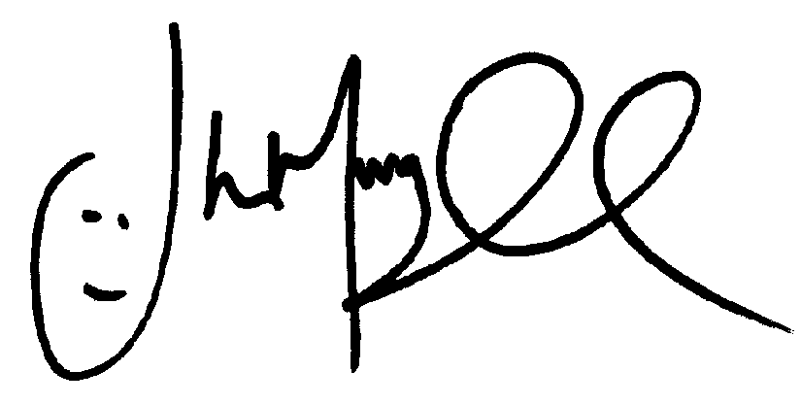
Mr J Murgatroyd
Head Teacher

