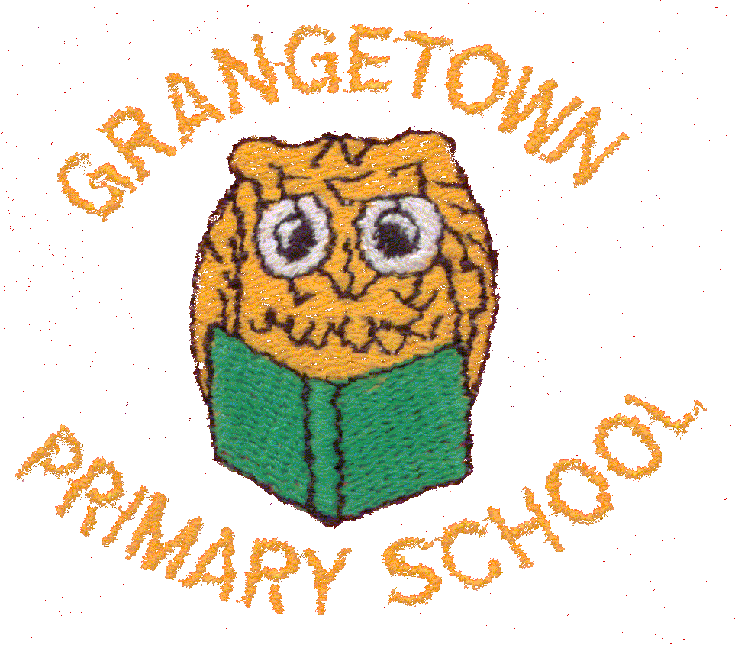Consent Form
The consent form below covers the following areas and informs parents and carers of our Policy in respect of the following:
Local trips
- I understand that my child may be taking part in local educational visits and I agree to my child taking part.
- I understand that my child will be walking to and from such visits, supervised by members of staff.
Photographs of children
- To comply with the Data Protection Act 1988, please sign the form below.
- I consent to my child being photographed or filmed.
- I consent to my child taking part in events that may be photographed and filmed.
Acceptable use policy for Information Communication Technology & the internet
- I give permission for my child to access the internet.
- I understand that the school will use a combination of filtering and supervision to ensure pupils cannot access inappropriate materials.
- I understand that the school cannot be held responsible for the nature or content of the material accessed through the Internet.
- I also understand that children may be given individual email accounts.
- I agree that the school is not liable for any damage arising from the use of the internet facilities.
- I agree that my child may access email through the School Learning Platform, when this is related to their work in school.
- This address may also be accessed from home, in which case supervision will rest with the Parents/Carers.
- I agree that, if selected, my child’s work may form part of the school website, blog or Twitter Feed.
- I also agree that photographs that include my child may be added to the site, blog or Twitter Feed.
- I understand that such photographs will be of general school activities rather than of individual children.
- Children’s full names will not usually be used on photographs or examples of work.
Working in Partnership
Equal opportunities
Home school agreement

To comply with the Data Protection Act 1988, please sign the form, if you consent to your child being photographed, or taking part in events that will be photographed or filmed.

Name of child________________________________

Signed ______________________________________

Date _________________

Further Information
Local trips
As you are aware each year your child may have the opportunity to walk and to visit a number of features of the local area, they typically include visits to the local library, Millennium Green, shops and churches. These visits are undertaken with a member of staff from the school and are subject to our usual policies for the management of visits.

Should a visit take place out of school hours, involving a cost to parents or venturing further afield, we will of course write to you to gain written permission. This form gives permission for your child to take part in the above activities; this involves walking to and from them. If any parent wishes to view our School Visits Policy then this is available from the Head Teacher.

Photographs of Children
Occasionally, we may take photographs of the children at our school. We may use these images in the school prospectus or in other printed publications that we produce, as well as on our school website, blog and Twitter Feed. We may also make videos or webcam recordings for school conferences, monitoring or other educational use.

From time to time our school may be visited by the media who will take photographs or film footage and pupils will often appear in these images. These images may appear in local or national newspapers, or on televised news programmes. Alternatively, parents often video or photograph productions or events in school, for example, the Christmas production.

To comply with the Data Protection Act 1988, please sign the form, if you consent to your child being photographed, or taking part in events that will be photographed or filmed.

Acceptable use policy for information Communication Technology & the Internet
Parents are requested to agree to the following:
- I give permission for my child to access the internet.
- I understand that the school will use a combination of filtering and supervision to ensure pupils cannot access inappropriate materials.
- I understand that the school cannot be held responsible for the nature or content of the material accessed through the Internet.
- I also understand that children may be given individual email accounts.
- I agree that the school is not liable for any damage arising from the use of the internet facilities.
- I agree that my child may access email through the School Learning Platform, when this is related to their work in school.
- This address may also be accessed from home, in which case supervision will rest with the Parents/Carers.
- I agree that, if selected, my child’s work may form part of the school website, blog or twitter feed.
- I also agree that photographs and videos that include my child may be added to the site, blog or twitter feed.
- I understand that such photographs and videos will be of general school activities rather than of individual children.
- Children’s full names will not usually be used on photographs, videos or examples of work.
A full copy of the current ICT Policy and E-Safety Policy is available on request.
Working in Partnership with other Agencies
From time to time staff may need to share basic information such as name, address and date of birth with other agencies or organisations. This will be done when it is deemed by the Head Teacher to be in the best interests of the child. Referrals to other agencies will be made wherever possible with parental consent.

Staff at our school work hard to ensure all children achieve to the best of their ability. With that in mind we make every effort to secure parental and carers support and involvement, this is often accomplished through; open evenings, activity days, newsletters and other special events.
From time to time staff at school will consult other agencies regarding the well being of individual or groups of pupils. Staff may seek advice on how to deal with a specific issue or difficulty. When a direct referral is made to any agency that is not statutorily involved with a child then it is school policy to seek parental or carer consent, except when seeking consent may place the child or others at further risk.

‘Every Child Matters’ meetings are hosted in school where concerns are discussed and then shared with other professionals from health, attendance, social care and other agencies. The Pastoral Manager maintains a record of such meetings and parents and carers are able to view the minutes, subject to confidentiality and the requirements of the data Protection Act 1988. In addition, staff may need to share basic information such as name, address and date of birth with other agencies and organisations.

Parents and Carers may also choose to raise concerns about their child’s well being with us. For example, parents may discuss academic matters with the child’s class teacher or for other concerns with the School Pastoral Manager (Mrs Ackerley). The Head teacher is available most days and of course parents may make an appointment to discuss a specific issue. In addition, we benefit from regular visits from the School Nurse, Police & Community Support Officers as well as the local Wardens.

Equal Opportunities
At Grangetown Primary School we will continuously strive to ensure that everyone in our school is treated with respect and dignity. Each person in our school will be given a fair and equal opportunity to develop their full potential with positive regard to gender, ethnicity, culture and religious background, sexuality and disability. We will actively promote equality and oppose discrimination in all its forms and foster positive attitudes and commitment to an education for equality. We aim to achieve this by:
- Taking active measures to investigate, report and act on incidents of abuse.
- Treating all those within the whole school community as individuals with their own particular abilities, beliefs, challenges, attitudes, background and experiences.
- Creating a school ethos that promotes equality, develops understanding and challenges myths, stereotypes, misconceptions and prejudices.
- Encourages everyone within the school community to gain a positive self image and high self esteem.
- Having high expectations of everyone involved with the whole school indentifying and removing all practices, procedures and customs which are discriminatory and replacing them with practices which are fair to all.
- Promoting mutual respect and valuing each others similarities and differences and facing equality issues openly.
- Monitoring, evaluating and reviewing the above to secure continual improvements.
- Working with the Council in reducing the number of racially motivated incidents, including those motivated by race, gender or other factors.

Grangetown Primary School

Grangetown Primary School is a friendly, welcoming learning community committed to creating the best possible educational experience for every child.
We begin caring for our pupils from the minute the family walk through the door. We believe that each step of every child's education is as important as the one before. We strive to provide inspiring and memorable learning experiences throughout their learning journey.
We recognise that children learn in different ways and that they learn best when their emotions are engaged and that learning should be fun, creative and allow the children to experience many different enriching activities that broaden their horizons and raise their aspirations.
Through these experiences we believe that our pupils will become happy, secure responsible young people who have a sense of belonging to our community, which in turn is proud of them.
We want to foster and develop positive relationships and clear communication between parents, pupils and staff. We provide a warm welcome and a listening ear to parents and pupils views and concerns. We place a high importance on positive social behaviour and respect for each other which we see as an important component of their whole education.

Parent I will try my best to | Pupil I will try my best to | School we aim to
- See that my child attends school regularly and on time, informing the school immediately of reasons for absence.  - Ensure that my child is dressed according to the school rules and is properly equipped for lessons, including bringing their P.E kit in each week.  - Support with your child’s homework.  - Provide opportunities for learning at home.  - Attend open afternoons at the end of every half term to discuss your child’s progress with the teacher.  - Support the school in promoting good behaviour. | - Respect other children’s culture, race, feelings, beliefs and values.  - Accept responsibility for the things that I do.  - Be responsible for my school and home work.  - Ask for help if I need it and try my best in all that do.  - Ensure that I take home all school letters.  - Follow the school’s Code of Conduct:  - Be kind and speak politely to everyone in school.  - Take good care of the building, equipment and school grounds.  - Behave in a safe way.  - Tell a member of staff if I am worried or unhappy. | - Provide a safe haven for our pupils a place where they feel safe, secure, cared for and wanted.  - Provide high quality creative education.  - Provide a wide range of experiences for our pupils to enjoy and take part in.  - Provide an enriching, fun and creative curriculum which captures the children's imagination.  - Provide an environment where children will thrive and become independent, confident learners.  - Foster cultural awareness and respect for people from different backgrounds and cultures.  - Provide a place where everyone shines with possibility and reaches their full potential.  - Make parents feel welcome and keep them informed.  - Provide a high standard of behaviour.

Welcome to the community of Grangetown Primary School
Mr J Murgatroyd Head Teacher

